List of Supplementary Tables

Supplementary Table 1. Table of Selected Phytochemicals with Favorable Drug-Likeness Properties: A MolSoft Drug-Likeness score > 0.50, molecular weight (MW) < 500 g/mol, and an Oral Bioavailability Score > 0.50.

Phytochemical name | Drug-likeness score | Bioavailability score | Molecular Weight (MW) | 2D Structure
Hesperetin | 0.59 | 0.55 | 302 g/mol | 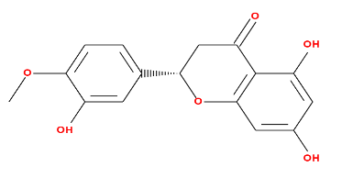
Cianidanol | 0.64 | 0.55 | 290 g/mol | 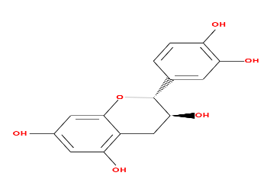
24-Methylenecholesterol | 0.51 | 0.55 | 398 g/mol | 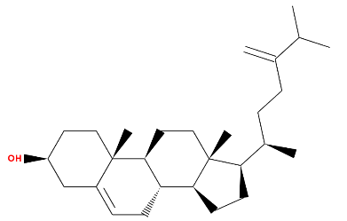
28-Isoavenasterol acetate | 1.2 | 0.55 | 468.8 g/mol | 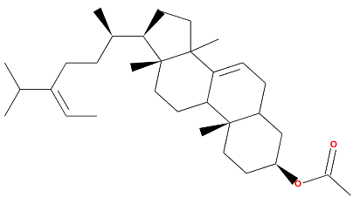
Campesterol | 0.59 | 0.55 | 400.7 g/mol | 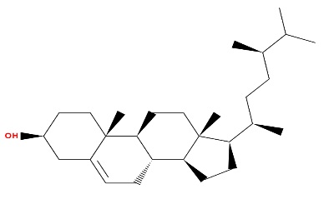
beta-Sitosterol | 0.78 | 0.55 | 414.7 g/mol | 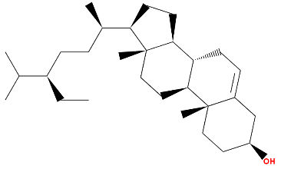

Supplementary Table 2. Top 10 Protein Interactions Ranked by Degree Method
Rank | Protein Name | Degree Score
1 | HSP90AA1 | 57
2 | SRC | 53
3 | STAT3 | 45
4 | MAPK1 | 41
5 | ESR1 | 39
6 | ARRB2 | 38
7 | BRD4 | 33
8 | MDM2 | 32
9 | NR3C1 | 31
10 | HIF1A | 31

Supplementary Table 3. Top 10 Protein Interactions Ranked by MCC Method
Rank | Protein Name | MCC Score
1 | AR | 156,694
2 | SRC | 155,850
3 | ESR1 | 155,796
4 | HSP90AA1 | 155,232
5 | HIF1A | 149,091
6 | MDM2 | 133,042
7 | PPARG | 132,009
8 | STAT3 | 107,732
9 | MAPK1 | 98,832
10 | ESR2 | 49,816

List of Supplementary Figures

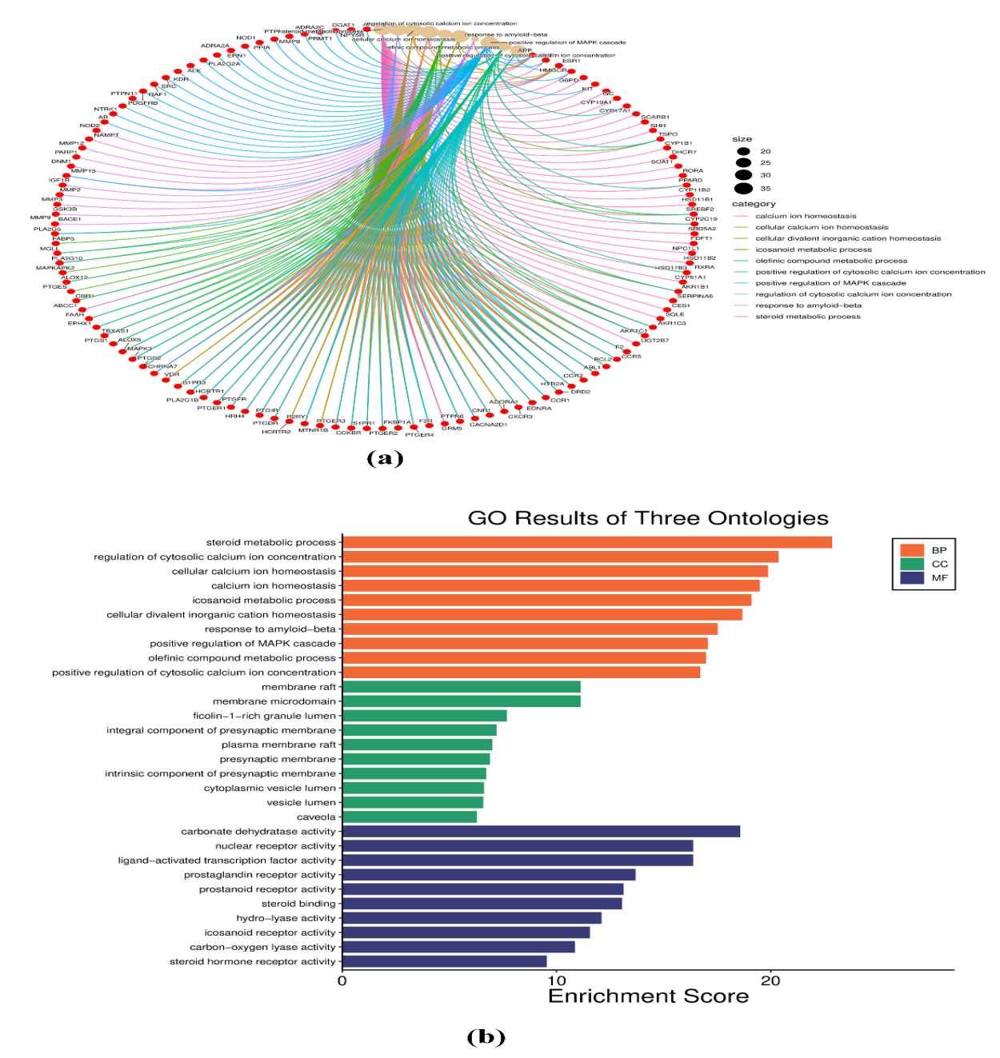
Supplementary Figure 1. Gene Ontology (GO) enrichment analysis of overlapping targets of M. oleifera and Alzheimer’s disease (AD). (a) Chord plot showing associations between hub genes (red nodes) and enriched biological processes. Lines connect individual genes to their corresponding pathways, with color-coded categories including calcium ion homeostasis, amyloid-beta response, MAPK signaling regulation, and steroid metabolism. (b) Bar chart of GO enrichment results across the three ontologies: Biological Process (BP), Cellular Component (CC), and Molecular Function (MF). The most enriched biological processes included steroid metabolic process, regulation of cytosolic calcium ion concentration, positive regulation of MAPK cascade, and response to amyloid-beta, highlighting pathways highly relevant to AD pathology.
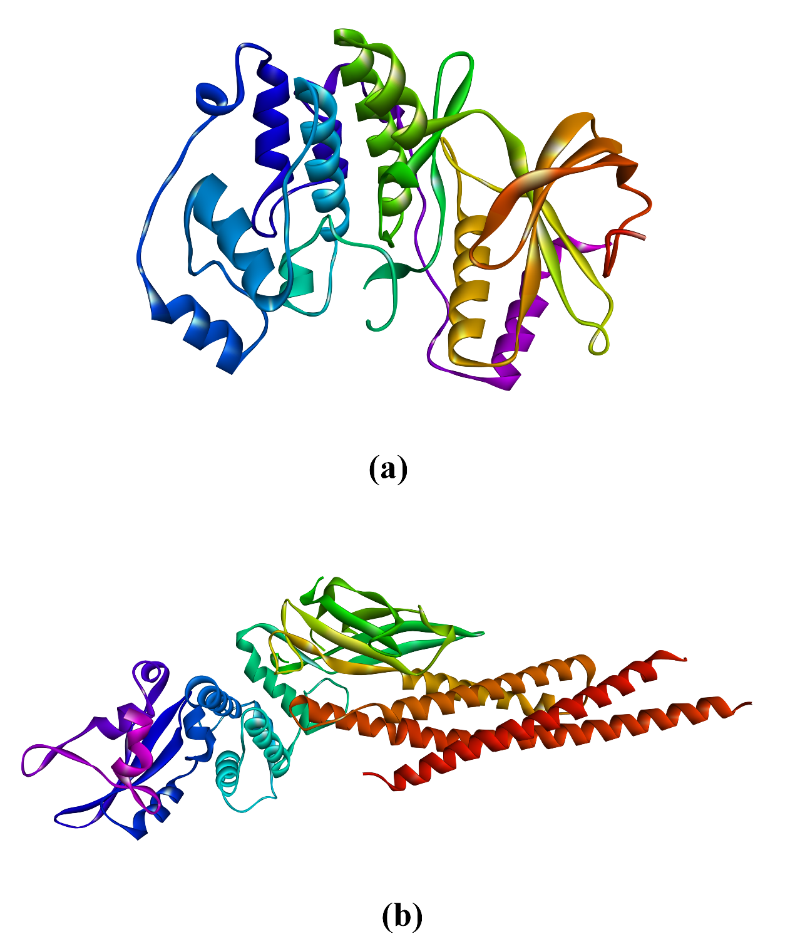
Supplementary Figure 2. (a) 3D structure of MAPK1 Protein (b) 3D structure of STAT3.
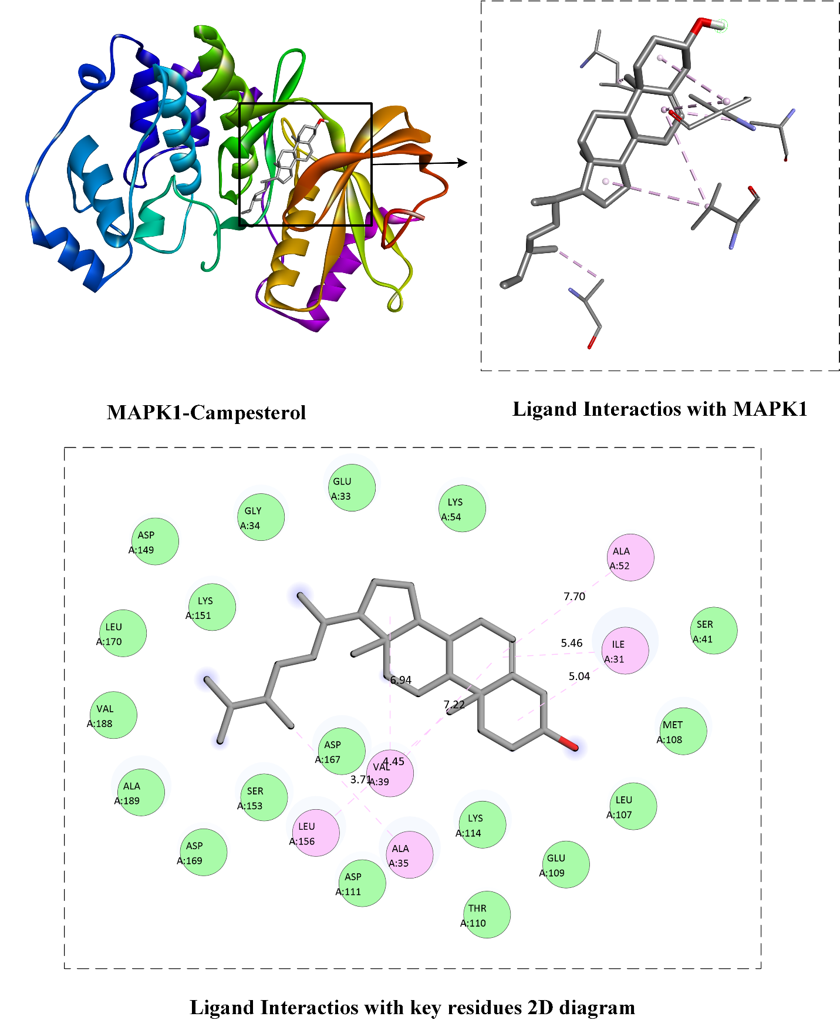
Supplementary Figure 3. Docking interaction of Campesterol with MAPK1 as illustrated in 3D and 2D interaction diagrams.
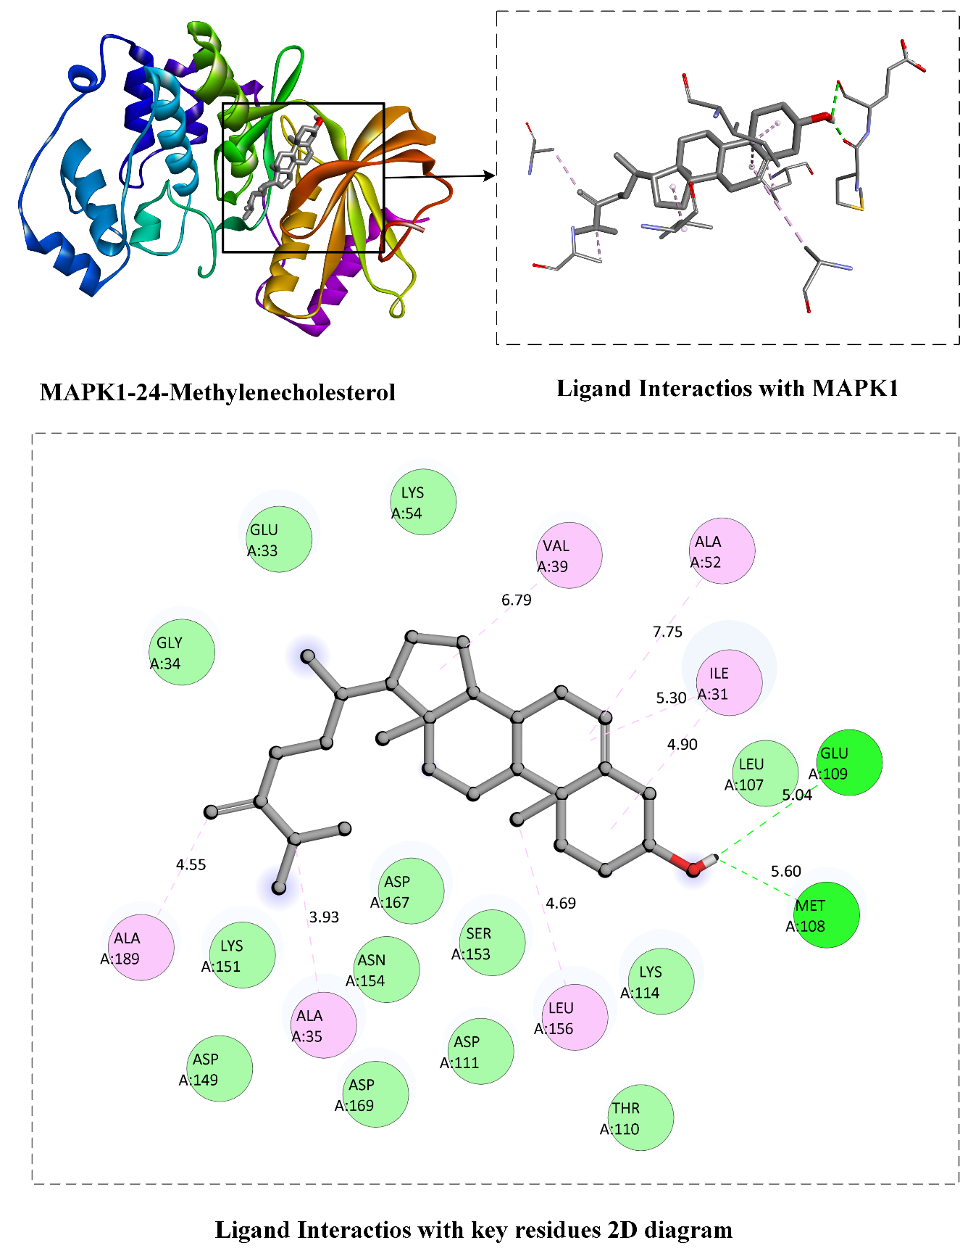
Supplementary Figure 4. Docking interaction of 24-Methylenecholesterol with MAPK1 as illustrated in 3D and 2D interaction diagrams.

