Configuration I
Figure S1
Simulated field distributions for channels Ch−1, Ch0, and Ch+1 under applied actuation: (a) +4.316 mN (1540, 1552, 1564 nm) and (b) −4.316 mN (1536, 1548, 1560 nm). Mechanical displacement is exaggerated for clarity (displacement scaled by a factor of 50).

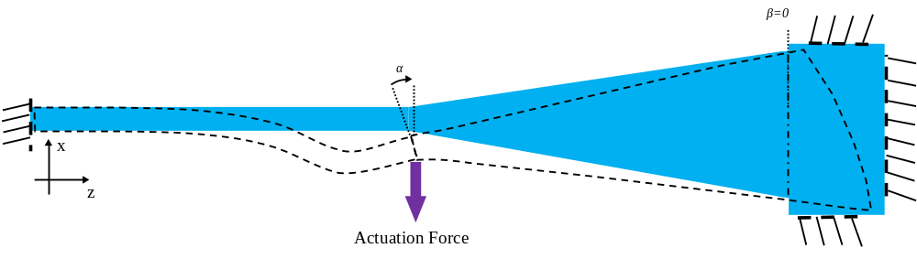
(a) +4.316 mN applied force | (b) -4.316 mN applied force
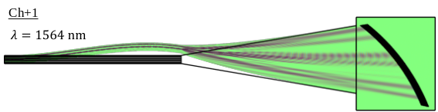 | 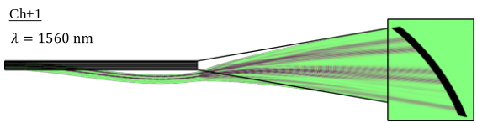
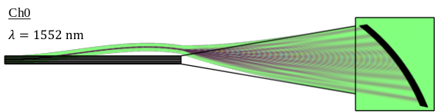 | 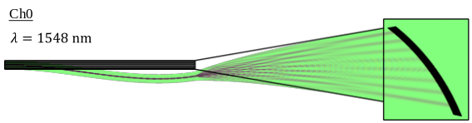
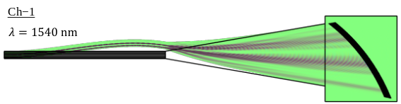 | 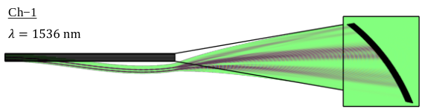

Configuration II
Figure S2
Simulated field distributions for channels Ch−1, Ch0, and Ch+1 under applied actuation: (a) +4.316 mN (1542, 1554.5, 1566.5 nm) and (b) −4.316 mN (1533.5, 1545.5, 1557.5 nm). Mechanical displacement is exaggerated for clarity (displacement scaled by a factor of 2).

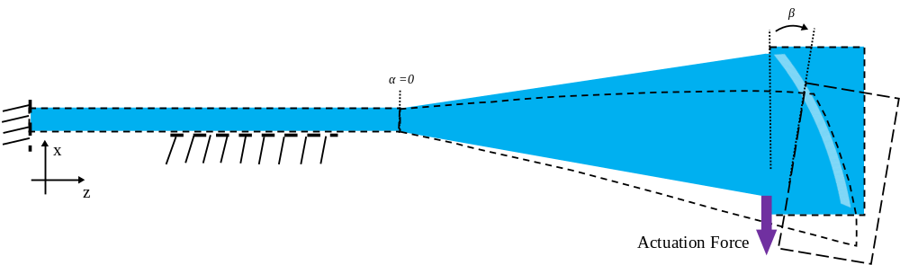
(a) +4.316 mN applied force | (b) −4.316 mN applied force
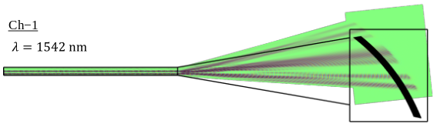 | 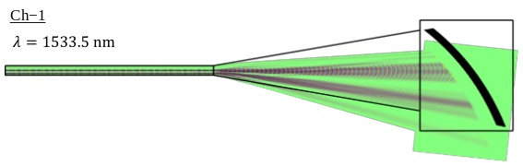
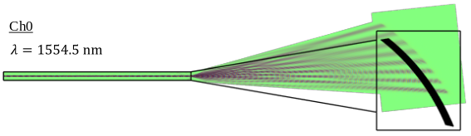 | 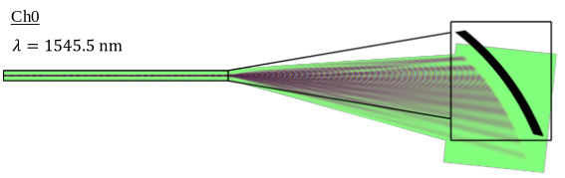
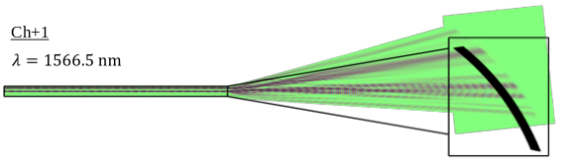 | 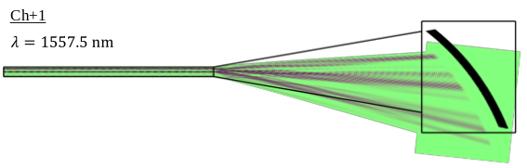

Configuration III
Figure S3
Simulated field distributions for channels Ch−1, Ch0, and Ch+1 under applied actuation: (a) +4.316 mN (1542, 1554.5, 1566.5 nm) and (b) −4.316 mN (1533.5, 1545.5, 1557.5 nm). Mechanical displacement is exaggerated for clarity (displacement scaled by a factor of 10).

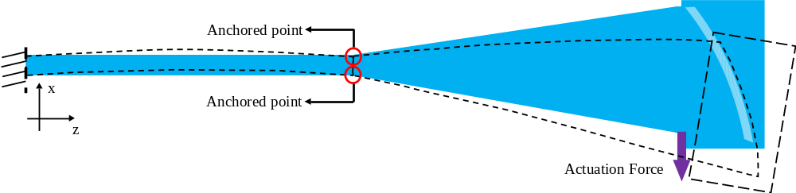
(a) +4.316 mN applied force | (b) −4.316 mN applied force
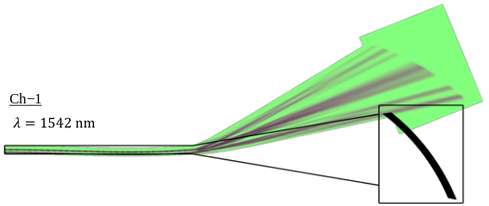 | 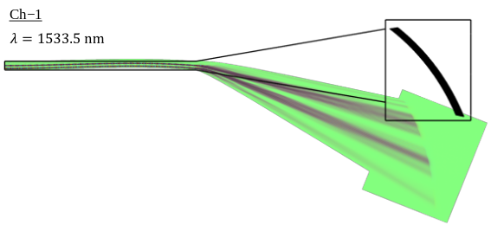
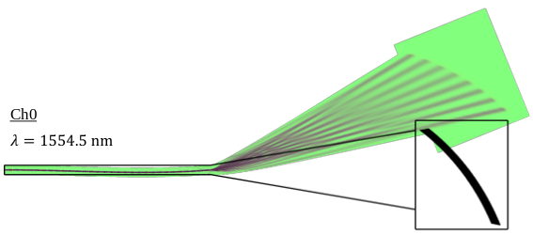 | 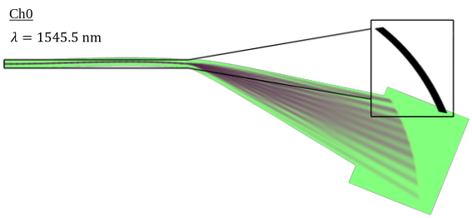
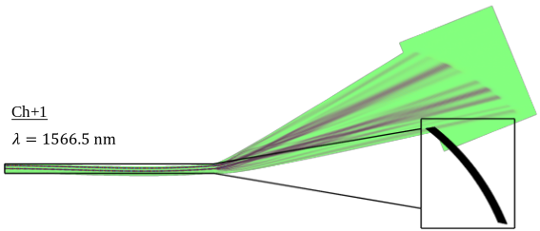 | 